

***Comprehensive Report***

***on***

**“Data Analytics and Data Visualization with Tableau”**

**(Summer Course)**

***Submitted by:***

|  |  |
| --- | --- |
| **Name:Veeresh Uppara**  **SRN:PES2UG19CS450**  **SEM:7** |  |

Faculty Handling the Course:

**Dr.Sudeepa Roy Dey**

**Dr.Prajwala TR**

**Prof.Ruby Dinakar**

**4th -9th, July 2022**

**DEPARTMENT OF COMPUTER SCIENCE AND ENGINEERING**

##### PES UNIVERSITY, EC campus

(Established under Karnataka Act No. 16 of 2013) Electronic City, Hosur Road, Bengaluru – 560 100, Karnataka, Ind

Table of Contents

The CSE CIC AWS Dataset

1.Data Analytics

1.1 Correlation between attributes

1.2 Monotonic functions

2.Data Analytics-ML Model

SVM Model

3.Data Analytics With Tableau And Insights

**The CSE CIC AWS Dataset**

A dataset with 80 columns and around 1 million records. Popular for intrusion detection systems.

Various types of attacks have been taken-Dos, Brute Force, SQL injection, FTP and SSH attacks, DDoS like SYN flood and UDP floods.

**1.Data Analytics**

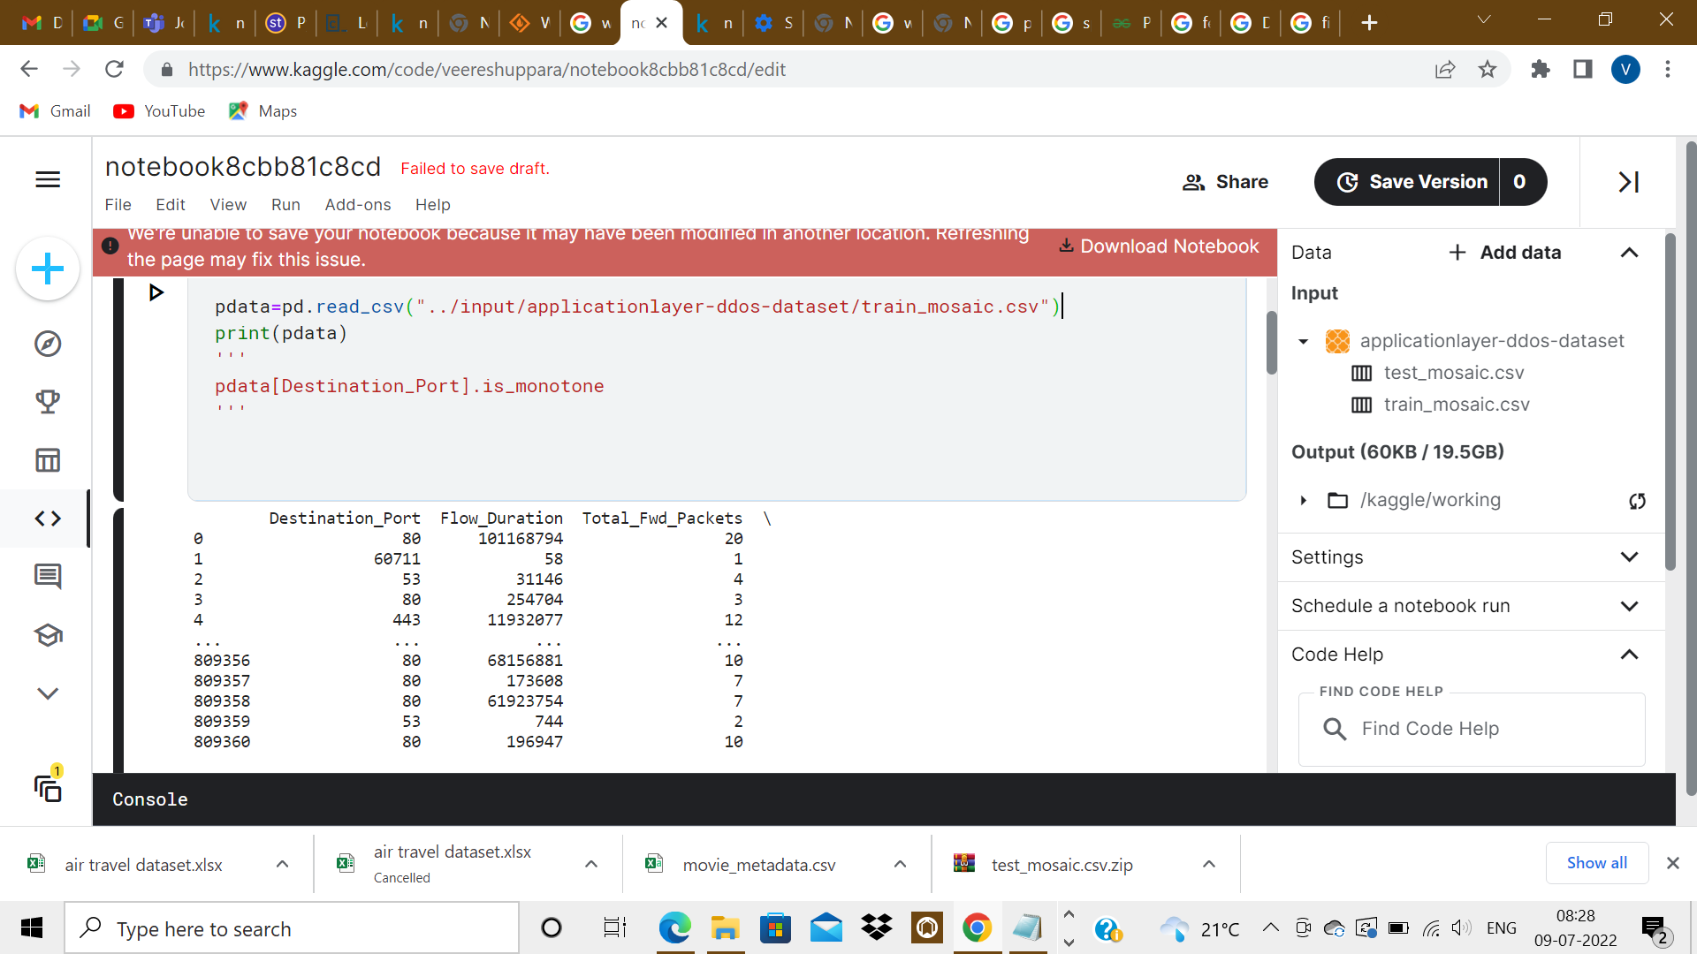

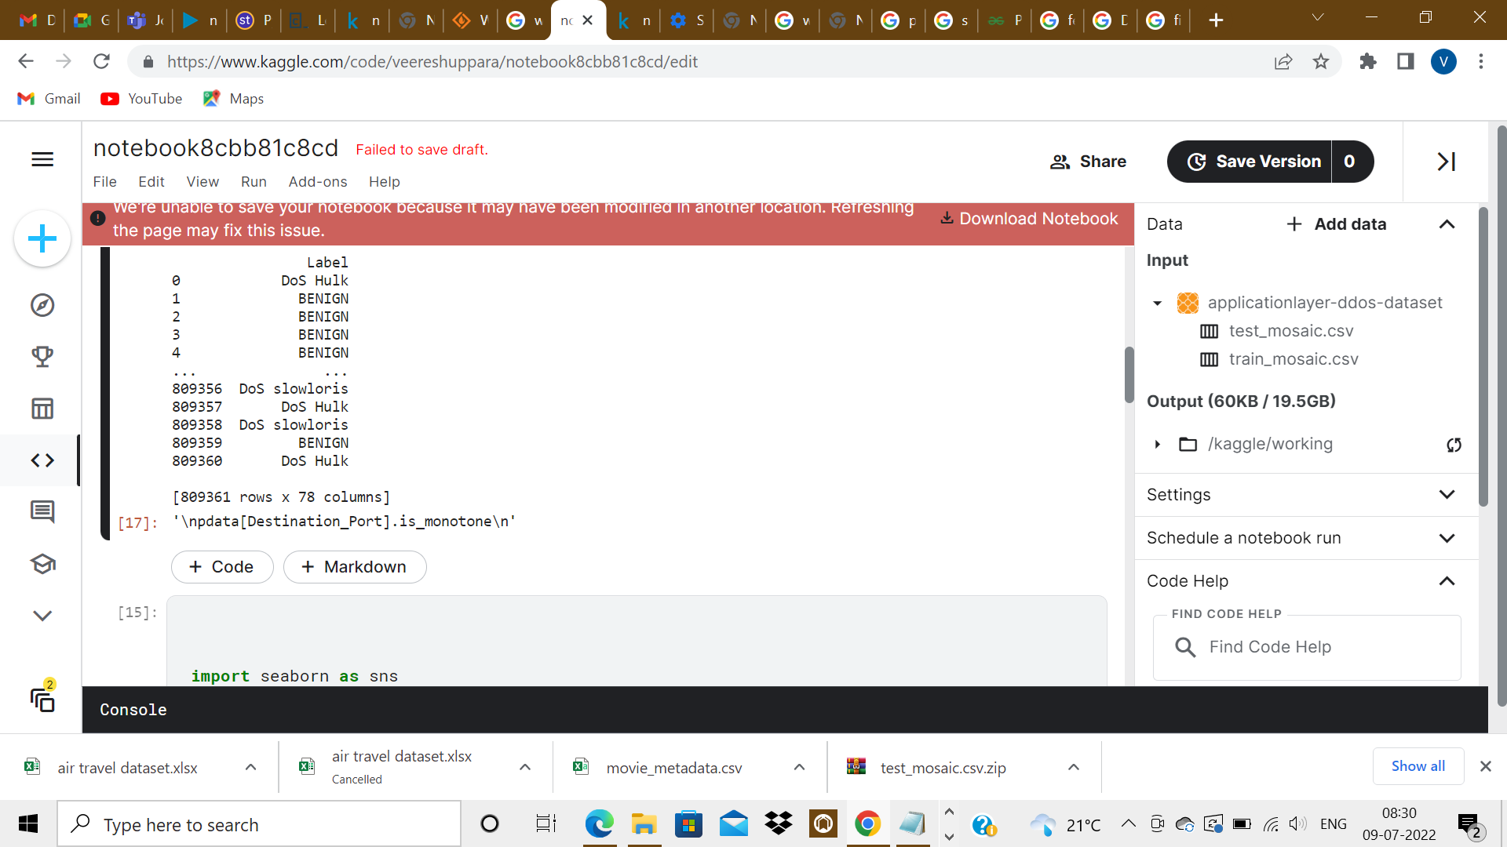

**1.1Correlation with heatmap**

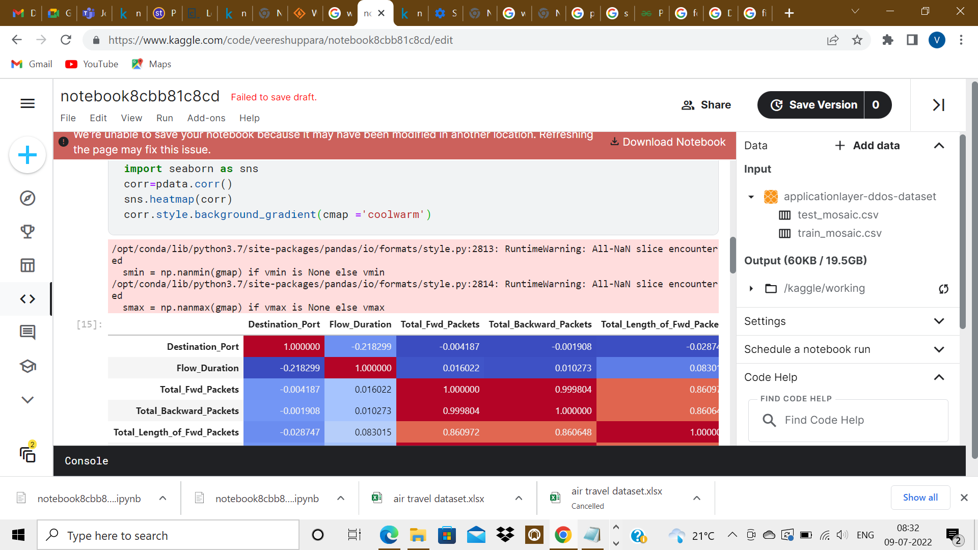

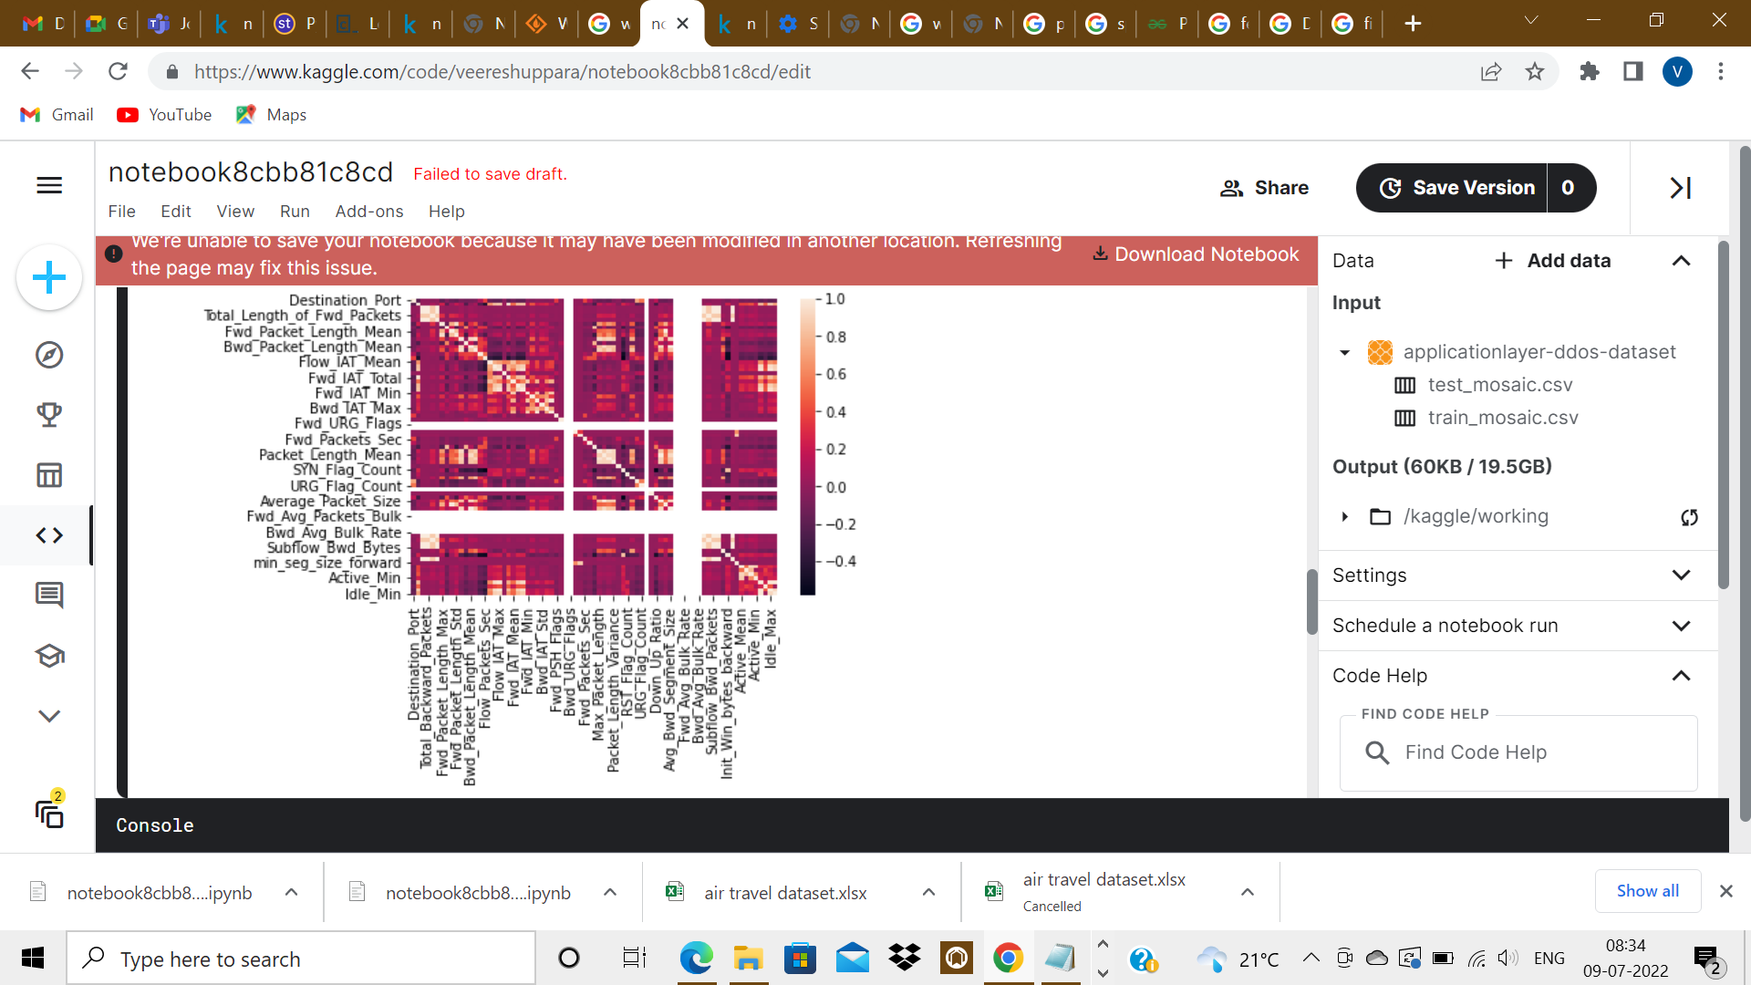

**1.2Monotonous Functions**

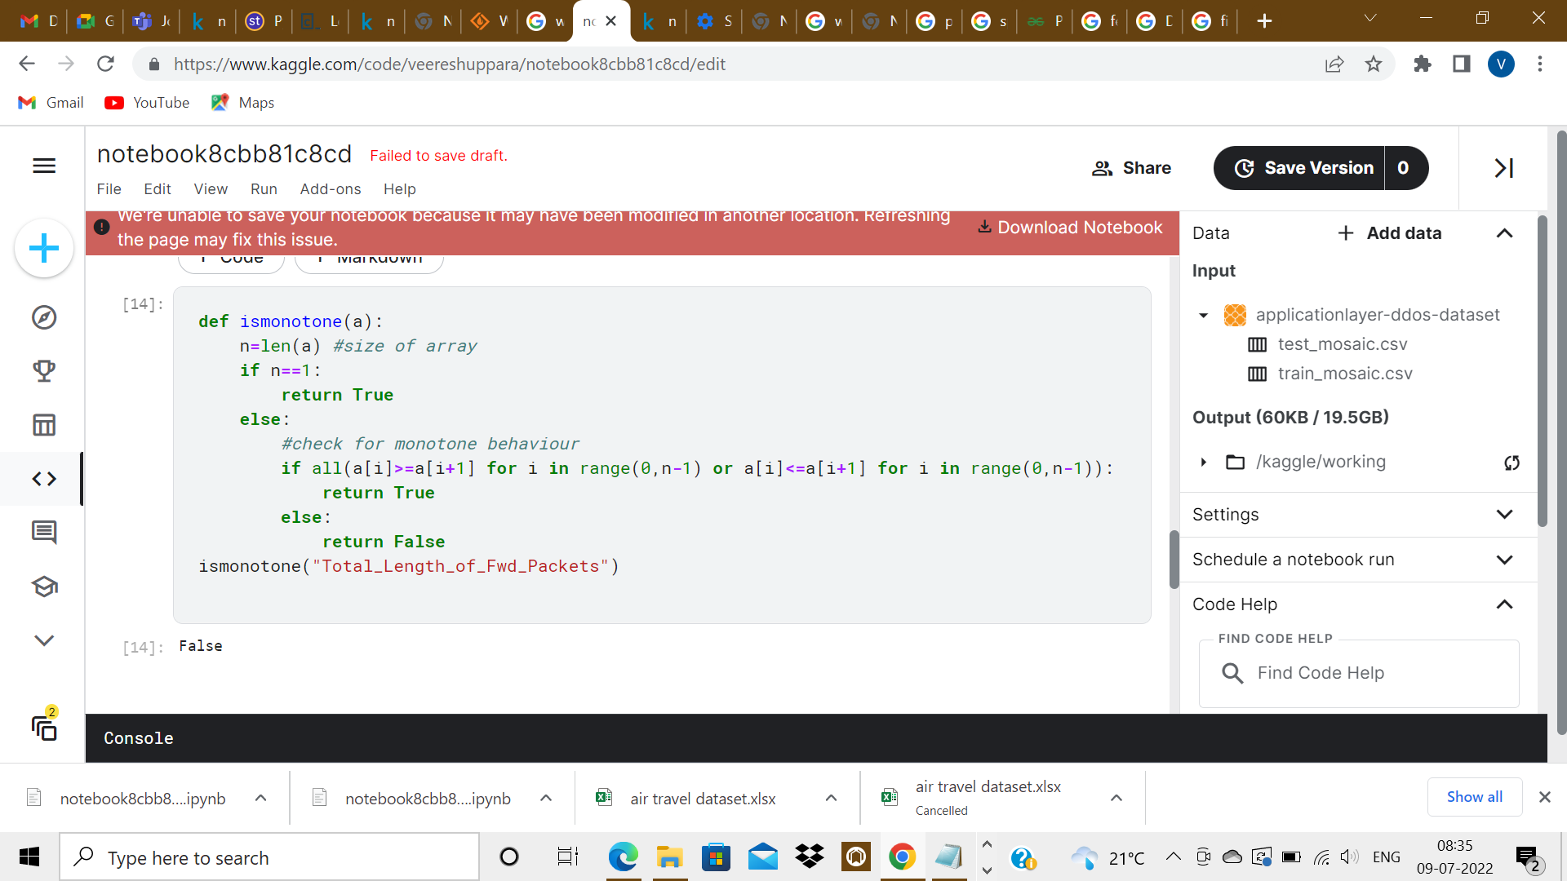

-The columns of the dataset aren’t monotonous.

**2.Data Analytics-ML model for the dataset**

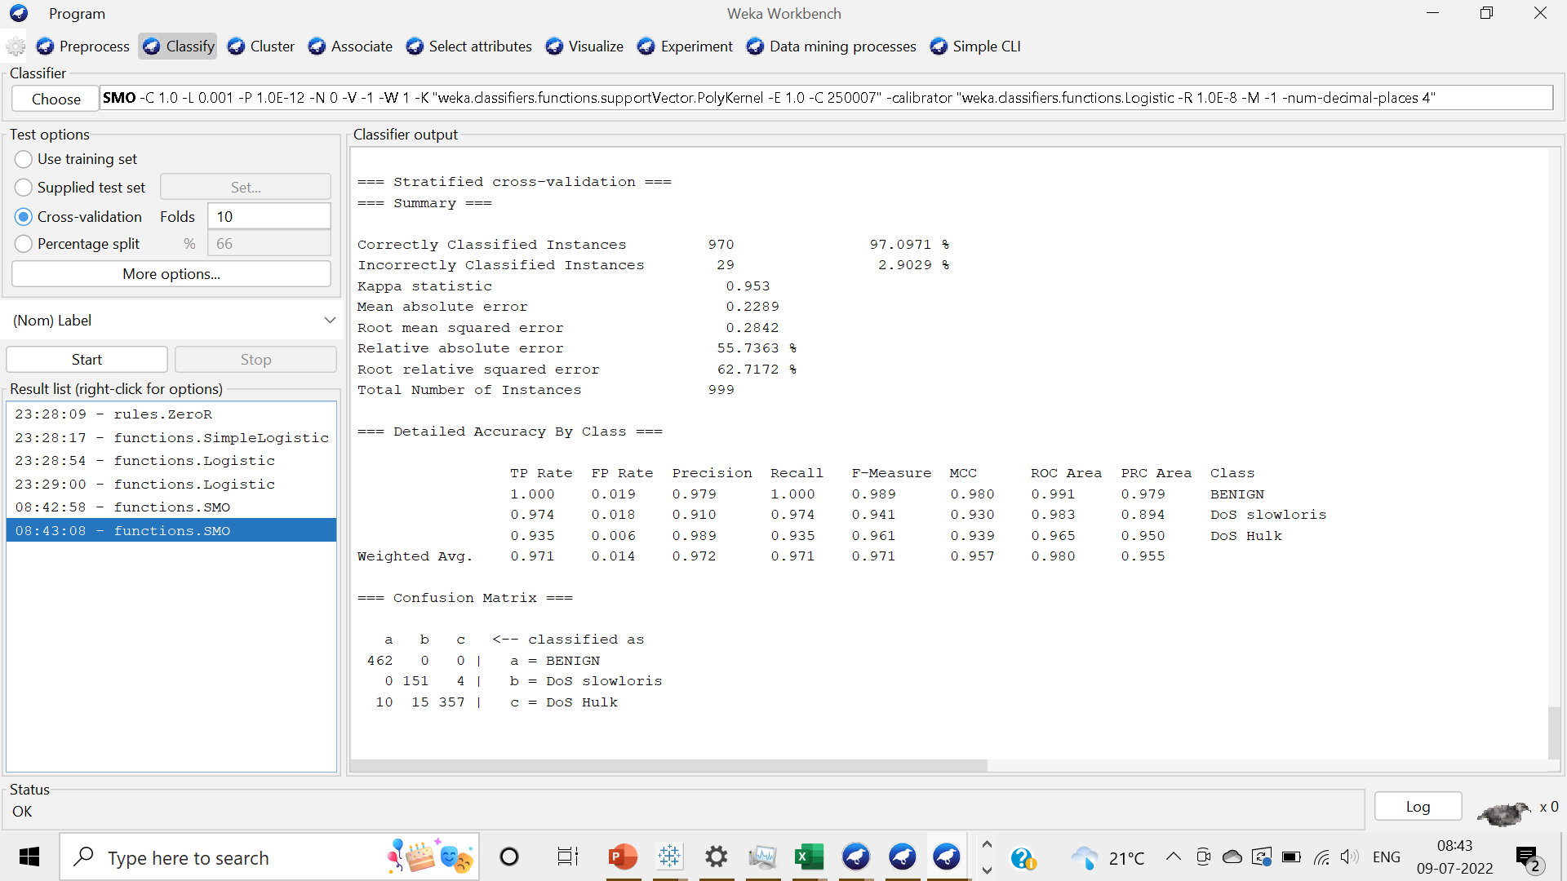

SVM Model chosen-SMO function performs the SVM on the dataset.

K value chosen-10

3.Data Analytics With Tableau And Few Insights

3.1.1

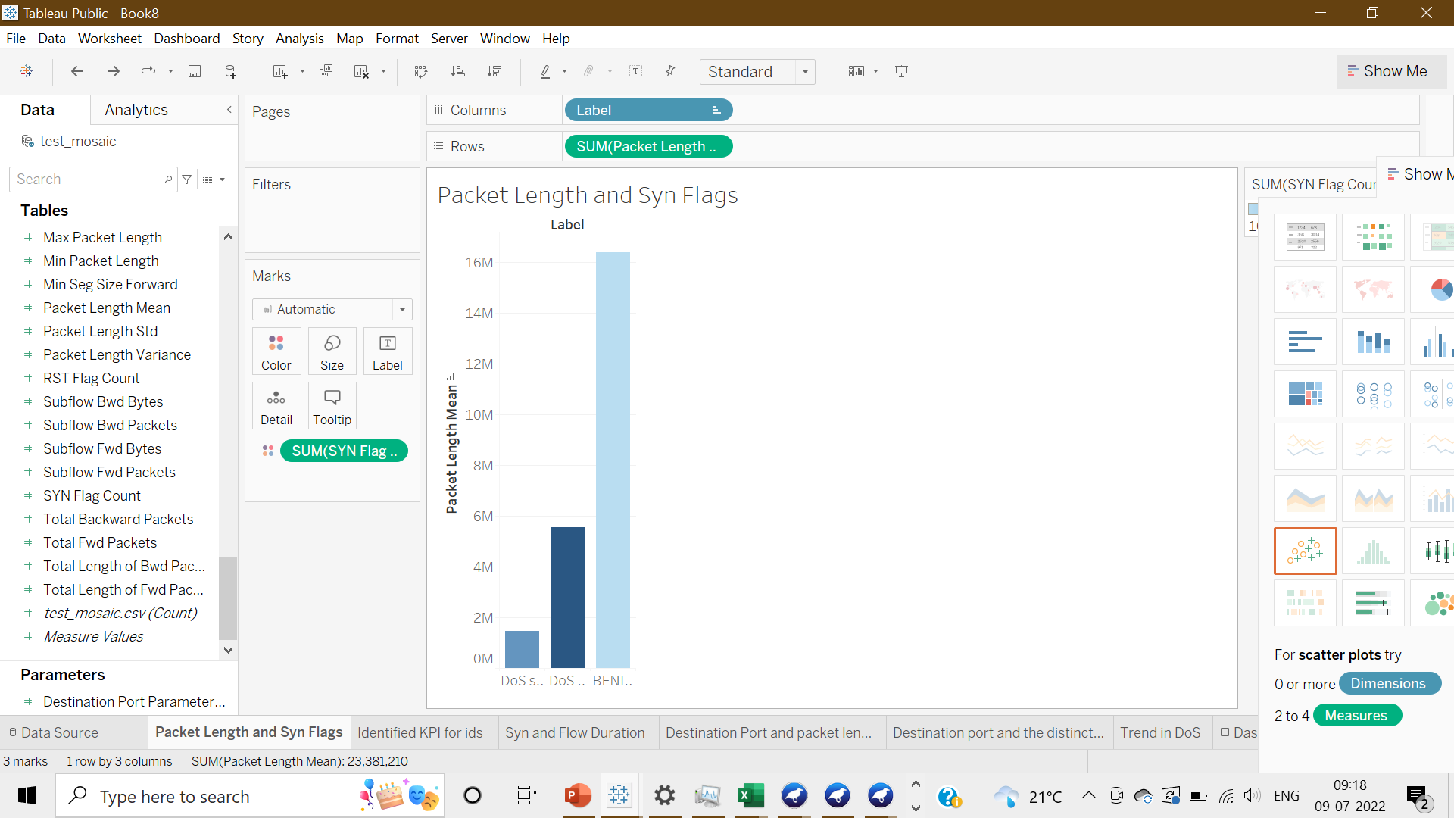

Packet Lengths, when IP is Benign are Large which simply means when attackers target servers, they focus more on other aspects than the packet length.

3.1.2

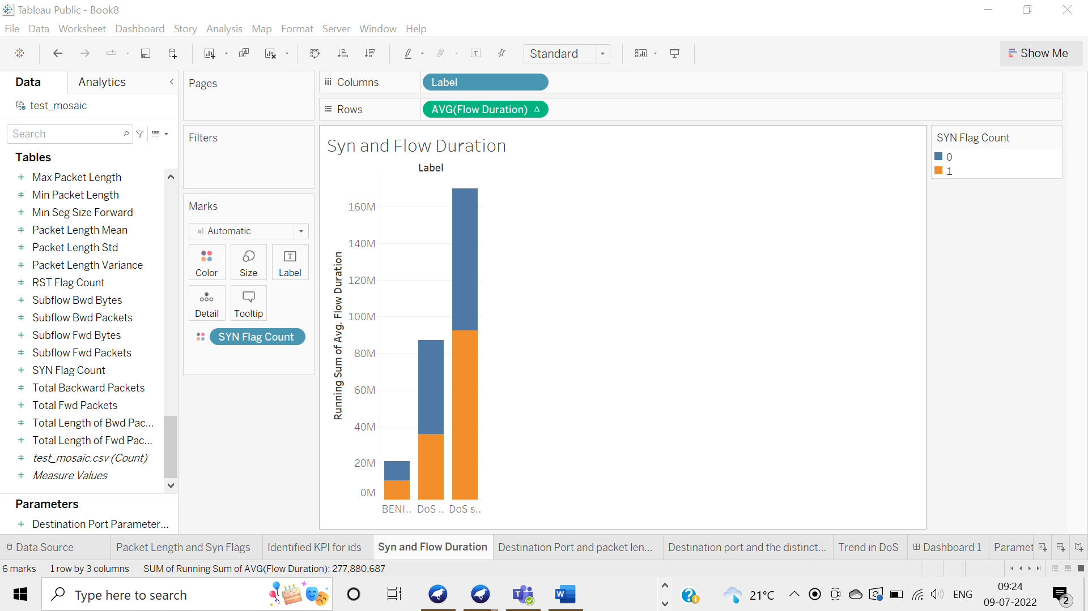

In DDoS, an IP address makes many connections with SYN bit and slow down the server.

3.1.3

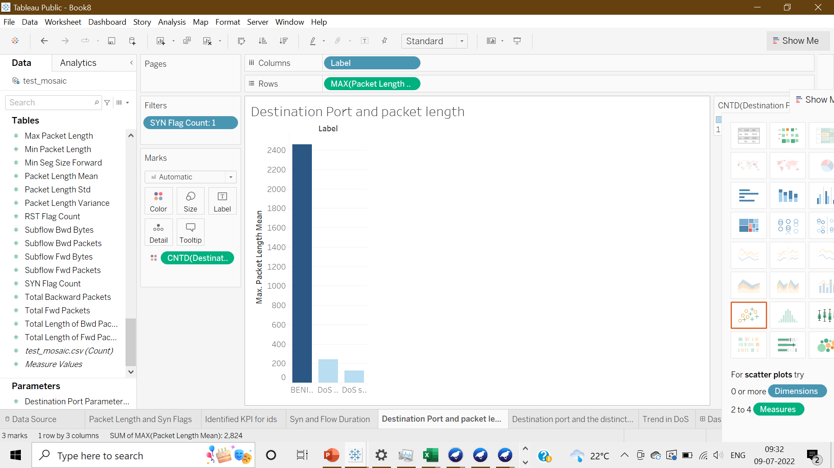

Dos target specific services

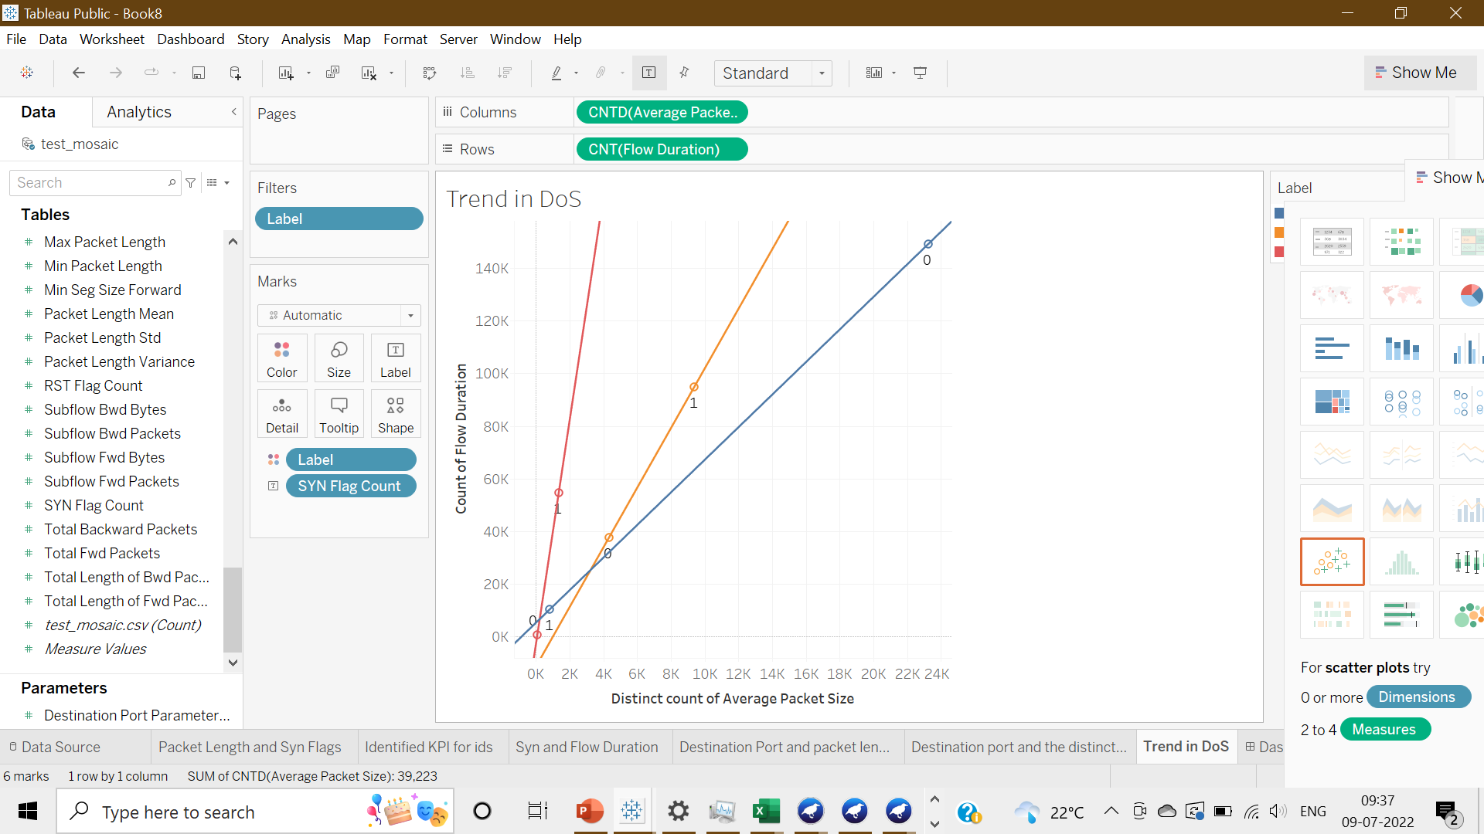

Dos after connecting to the server has a greater Flow duration =>It keeps the server busy making other valid clients wait for more time to get the same service.

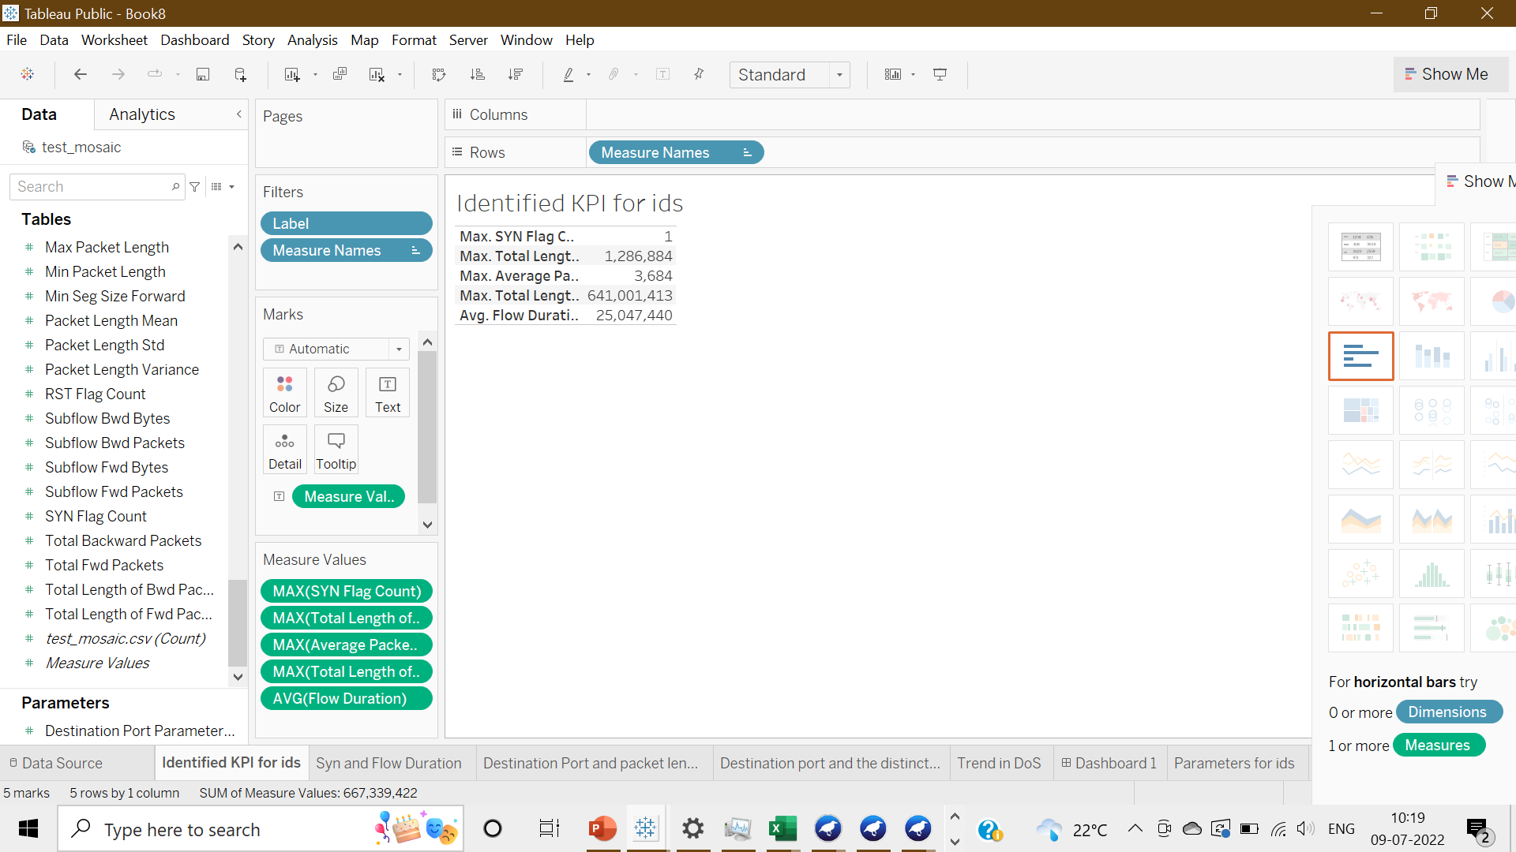

KPI values

3.1.4

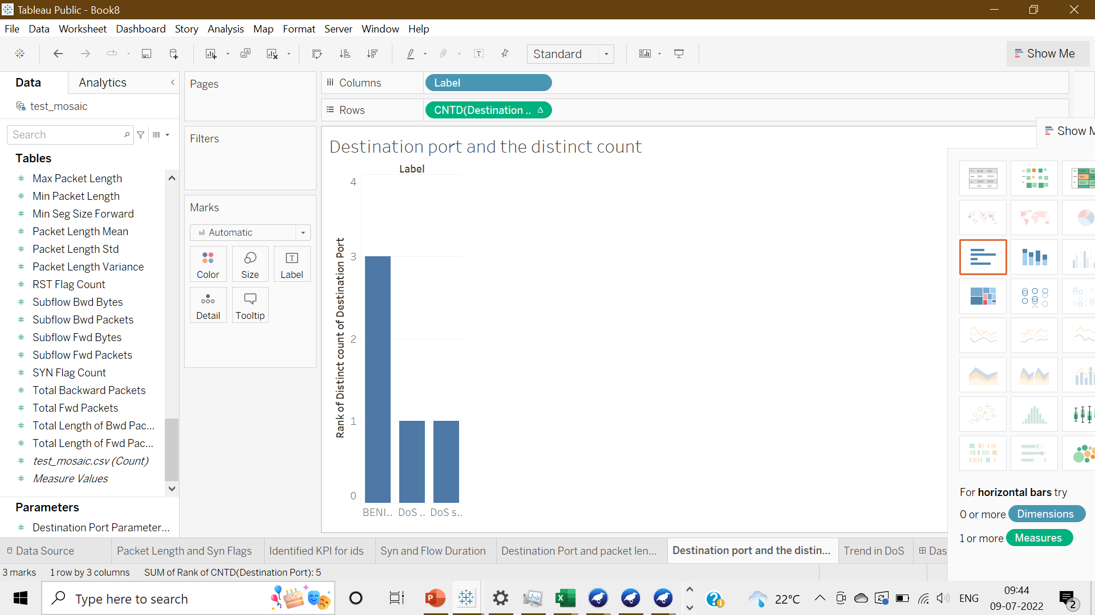

-DoS Slowloris and Dos Hulk target specific ports.

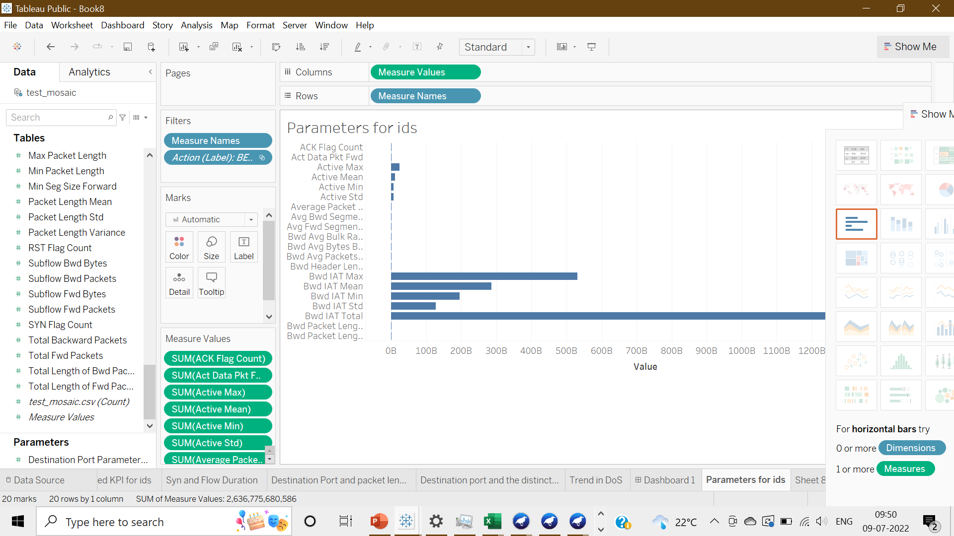

-The attributes that play a role in the intrusion detection system.

3.1.5

